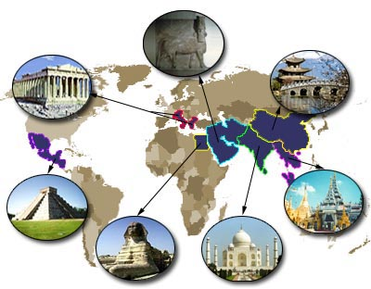

Project Overview

Core 4 students will research to build knowledge around different Ancient Civilizations, specifically Egypt, India, and China. Through this research, teams of students will come to understand ancient religions, and what those religions look like today. We will accomplish this through various hands-on activities, guest speakers, and team research/mini presentations. Through this process, we will come to understand how these ancient religions are now the center of wars and religious persecution, causing people to seek refuge away from their homes. Ultimately, our goal is to use our knowledge to affect positive change in the world by sending soap to those affected by religious persecution/refugees at home and abroad. Students will also have a choice in what kind of narrative writing they create to accompany their soap.



**Skills/Standards**

**READING INFO:**

**Key Ideas and Details:** Read closely to determine what the text says explicitly and to make logical inferences from it; cite specific textual evidence when writing or speaking to support conclusions drawn from the text.

**Craft and Structure:** Analyze the structure of texts, including how specific sentences, paragraphs, and larger portions of the text (e.g., a section, chapter, scene, or stanza) relate to each other and the whole.

**Integration of Knowledge and Ideas**: Analyze how two or more texts address similar themes or topics in order to build knowledge or to compare the approaches the authors take.

**WRITING**:

**Text Types and Purposes:** Write narratives to develop real or imagined experiences or events using effective technique, well-chosen details, and well-structured event sequences.

HISTORY:

Students analyze the geographic, political, economic, religious, and social structures of the early civilizations of the Ancient Hebrews, Ancient India, and Ancient China

Driving Questions

What can we discover about the Ancient Civilizations of India, Egypt, and China? How are they similar and different from Mesopotamia? From America? What religion did they practice? Where do people practice those religions today, and what does that look like? Why might people be persecuted for practicing these religions? How can we support people seeking refuge for religious or other reasons?

**Due Dates**

2/23-2/24 Visual Presentation Part 1 in class

3/9-3/10 Visual Presentation Part 2 in class

3/23-3/24 Visual Presentation Part 3 in class

3/30-3/31 EXHIBITION