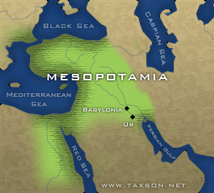

**Skills/Standards**

**Key ideas and details:** Read closely to determine what the text says explicitly and to make logical inferences from it; cite specific textual evidence when writing or speaking to support conclusions drawn from the text.

**Key ideas and details:** Determine central ideas or themes of a text and analyze their development; summarize the key supporting details and ideas.

**Craft and Structure:** Interpret words and phrases as they are used in a text, including determining technical, connotative, and figurative meanings, and analyze how specific word choices shape meaning or tone.

**Text Types and Purposes:** Write informative/ explanatory texts to examine and convey complex ideas and information clearly and accurately through the effective selection, organization, and analysis of content.

**Production and Distribution of Writing:** Produce clear and coherent writing in which the development, organization, and style are appropriate to task, purpose, and audience

Students analyze the geographic, political, economic, religious, and social structures of the early civilizations of Mesopotamia

**Due Dates**

Tasks 1-10 should be completed by 12/5/14

Revisions to final draft sould be completed by

12/12/14

Book should be bound by 12/19/14

Driving Questions

How do we define a civilization? How have civilizations changed over time? What do you notice about Human Rights during Ancient Civilizations? What did the Mesopotamians do to set future civilizations up for success?

Project Overview

Welcome to our Mesopotamia project page! In order to really dive into Ancient Civilizations next semester, we need to be able to understand how the VERY FIRST civilization came to be, and how civilizations have changed over time. We will look closely at the characteristics of Mesopotamian civilization, and will explore what Human Rights looked like during this time. Each day, students will complete a series of tasks that will leave them with the information needed to create a well-crafted expository essay, in the form of a Mesopotamia book!